Assignment 3

Learning from Big Data
Rotterdam School of Management, Erasmus University
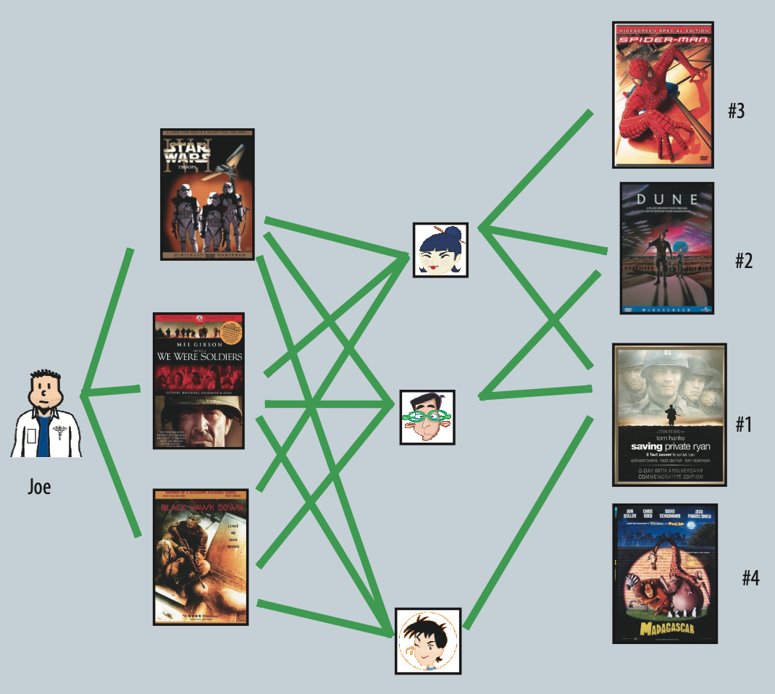

Due date: November 8, 2025
Student name: …

Background
In this homework assignment, you will write a review for a research article. The article chosen for this task is (see Canvas)
Koren, Y., Bell, R., & Volinsky, C. (2009). Matrix factorization techniques for recommender systems. Computer, 42(8), 41-47.
This paper presents an interesting and very relevant application technique that won the Netflix competition, and has been used by many other companies since then. The article also highlights some valuable recommender systems strategies and challenges that are important in practice for a real-world business setup.
In your review of this article, you will also reflect on the lessons learned during class and in the first two assignments, and how they can be used to develop a MAB for the same purpose as the technique used in this paper. The assignment will help you to learn how to design MAB to tackle long-standing problems.
Task
Your report should contain five key points:
First, start with a concise summary of the paper to show that you understand the gist of the paper. Read the introduction several times. What is the goal of the article? How do they achieve it? What are the key results generated by this research? Consider the relationships between the key concepts presented in the introduction. Consider creating a concept map of the key ideas (i.e., a figure showing the relationship between the different ideas). Then, read the methods and results sections, including all graphs and figures provided in those sections. What are the most important results? Finally, read the conclusion. Does the conclusion agree with your assessment of the results?
Second, critically think about the paper’s contribution. What is the type of contribution? This overview (https://pubsonline.informs.org/page/mksc/submission-guidelines - see section Manuscript Objectives) can help you with identifying the contribution. Is the contribution relevant, novel, and interesting?
Third, discuss the major strengths and weaknesses of the paper. Did you learn something new? Are the key findings important? Was the study original? Were you convinced by how the study was executed? What would convince you even more? Pay attention to what the authors did well and what could be done better.
Fourth, explain what practical lessons you have learned from the paper about machine learning. How do these lessons connect to the course content?
Fifth, imagine you are tasked to write a follow-up paper to Covington, Koren, Bell and Volinsky (2009) that instead of matrix factorization, uses MAB. What research questions would you prioritize? How would you tackle them? Can you outline a MAB to run and compare against matrix factorization? What would be the arms, what would be possible outcome measure(s), what would the MAB be learning? Do your best to outline it as you can.
Use the above five points to structure your review. Your submission must contain the following deliverable: 1. Your report: `Assignment_3_ERNANUMBER.pdf`
Please submit your report (pdf) to Canvas before the deadline.
A final point, relax and read the paper with an open mind. Enjoy learning details about someone else’s research. Start early and re-read the article several times. Reading the manuscript early will help you estimate and schedule enough time to complete the review by the deadline. Read through the manuscript carefully, noting any questions and making comments.

All the best and have fun ☺!

Prof. Gui Liberali

This obviously has to be written by, not by LLM nor someone else.

